- Write a programme in openGL/p5.js/other to illustrate different lights available in computer graphics.
https://p5js.org/reference/#/p5/lights
https://p5js.org/reference/#/p5/ambientLight
https://p5js.org/reference/#/p5/directionalLight
https://p5js.org/reference/#/p5/pointLight
let t=0;
function setup() {
createCanvas(300, 300,WEBGL);
}

function draw() {
background(255);
lights();
rotateY(t * 0.3);
rotateX(t * 0.3);
box(100);
t=t+0.05;
}
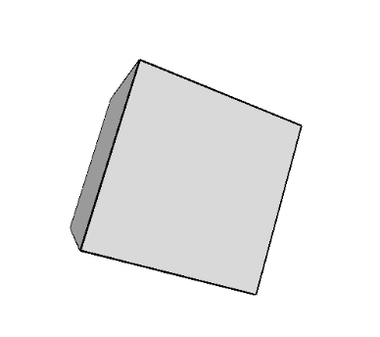
let t=0;
function setup() {
createCanvas(300, 300,WEBGL);
}

function draw() {
background(0);
ambientLight(200);
ambientMaterial(255,0,0);
rotateY(t * 0.3);
rotateX(t * 0.3);
box();
t=t+0.05;
}
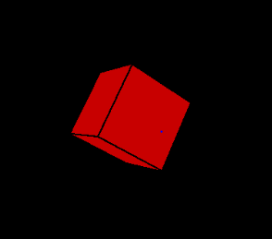

function setup() {
createCanvas(100, 100,WEBGL);
}
function draw() {
background(255);
let dirX = (mouseX / width - 0.5) * 2;
let dirY = (mouseY / height - 0.5) * 2;
directionalLight(0, 0, 255,-dirX, -dirY, -1);
box(40);
}

let t=0;
function setup() {
createCanvas(100, 100,WEBGL);
}

function draw() {
background(255);
rotateY(t * 0.3);
rotateX(t * 0.3);
let dirX = mouseX - width / 2;
let dirY = mouseY - height / 2;
pointLight(255, 0, 0, dirX, dirY, 60);
box(40);
t=t+0.05;
}
